

DEPARTMENT OF MATHEMATICS
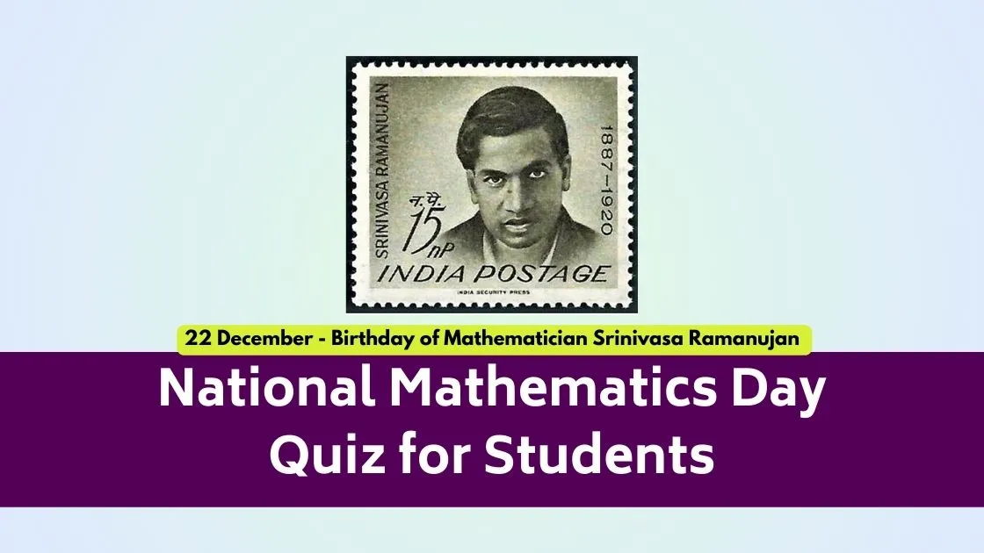

QUIZ PROGRAMME

Topic: General Mathematics

Date: 17 December 2025

1 | Date | 17 DECEMBER 2025
2 | Conducted through DRC/JKC/ELF/Dept.etc | Department of Mathematics
3 | Nature of Activity | Quiz Programme
4 | Title of Activity | National Mathematics Day Quiz for Students
5 | Name of the Department / Committee | Department of Mathematics
6 | Details of Resource person | Head mistress of Smt PSMC Girls High School, Headmistress of Mc Laurin High School and Faculty of Department of Mathematics
7 | No.of students participated | 198
8 | Activity outcomes: | - Improved computational and reasoning skills  - Better conceptual clarity in Mathematics  - Enhanced speed and accuracy  - Increased confidence in independent problem-solving
9 | Name of the lecturer who planned and conducted the activity | Department of Mathematics
10 | Signature of the In-charge | 
11 | Signature of the Principal | 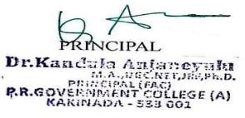

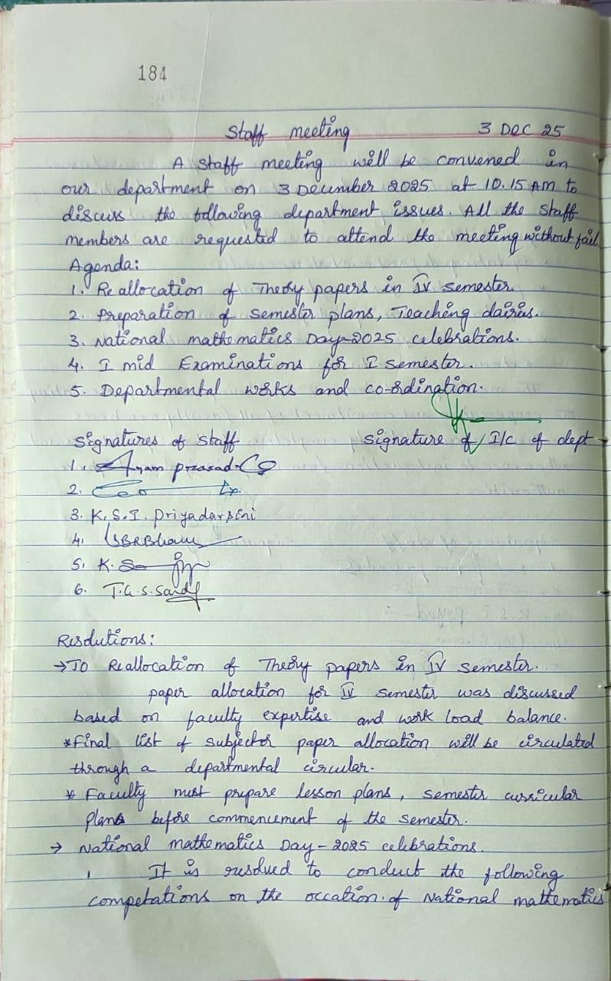
Department Minutes and Resolutions

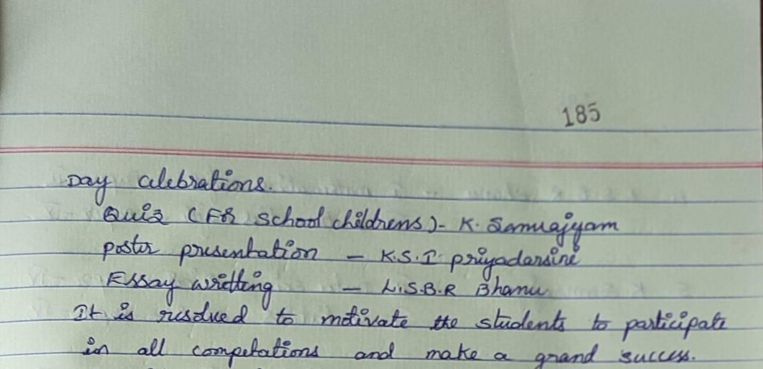

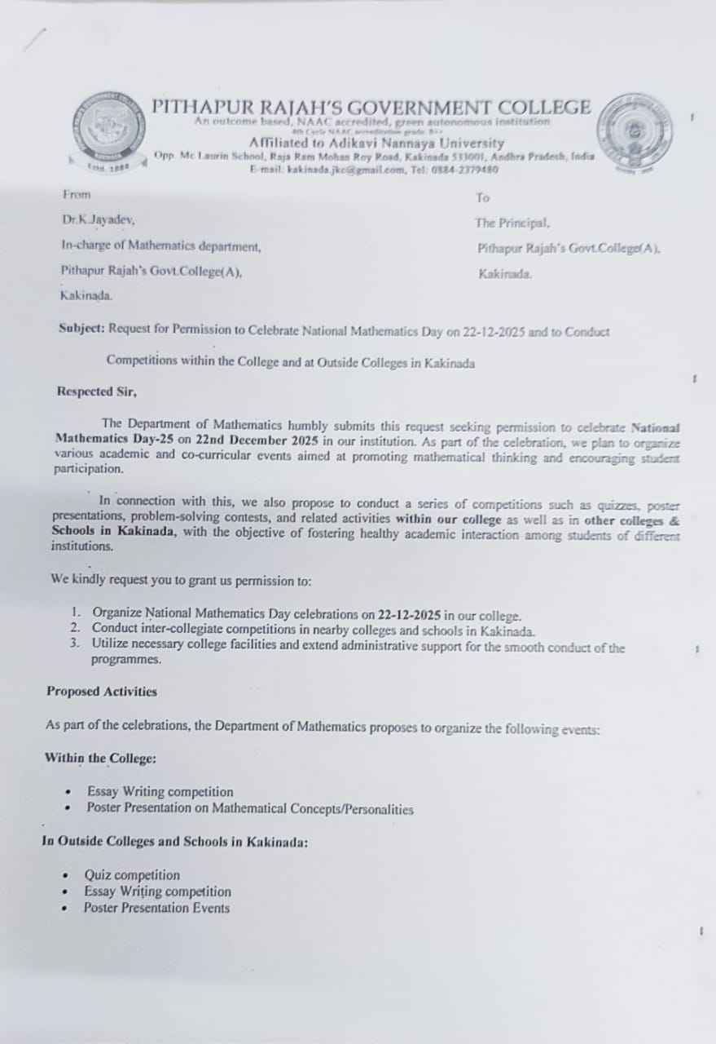
Principal permission letter
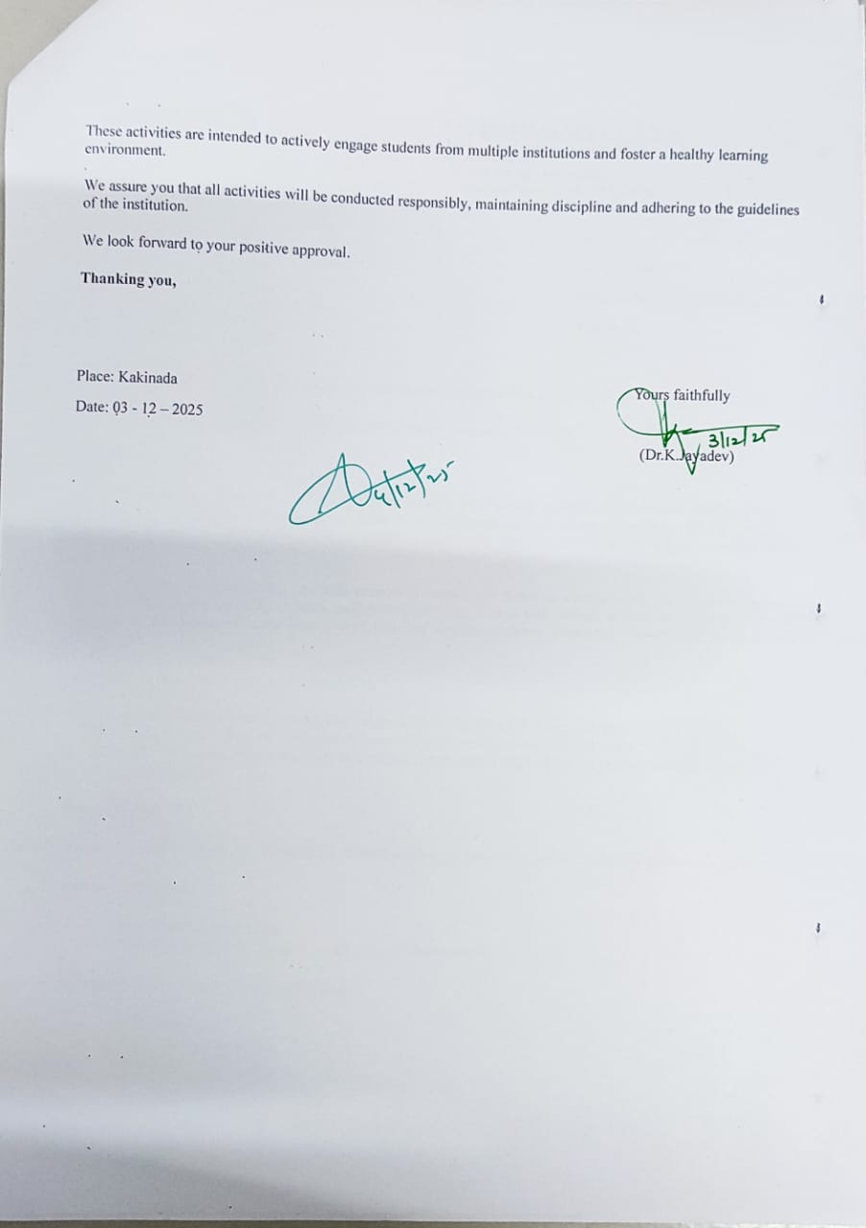

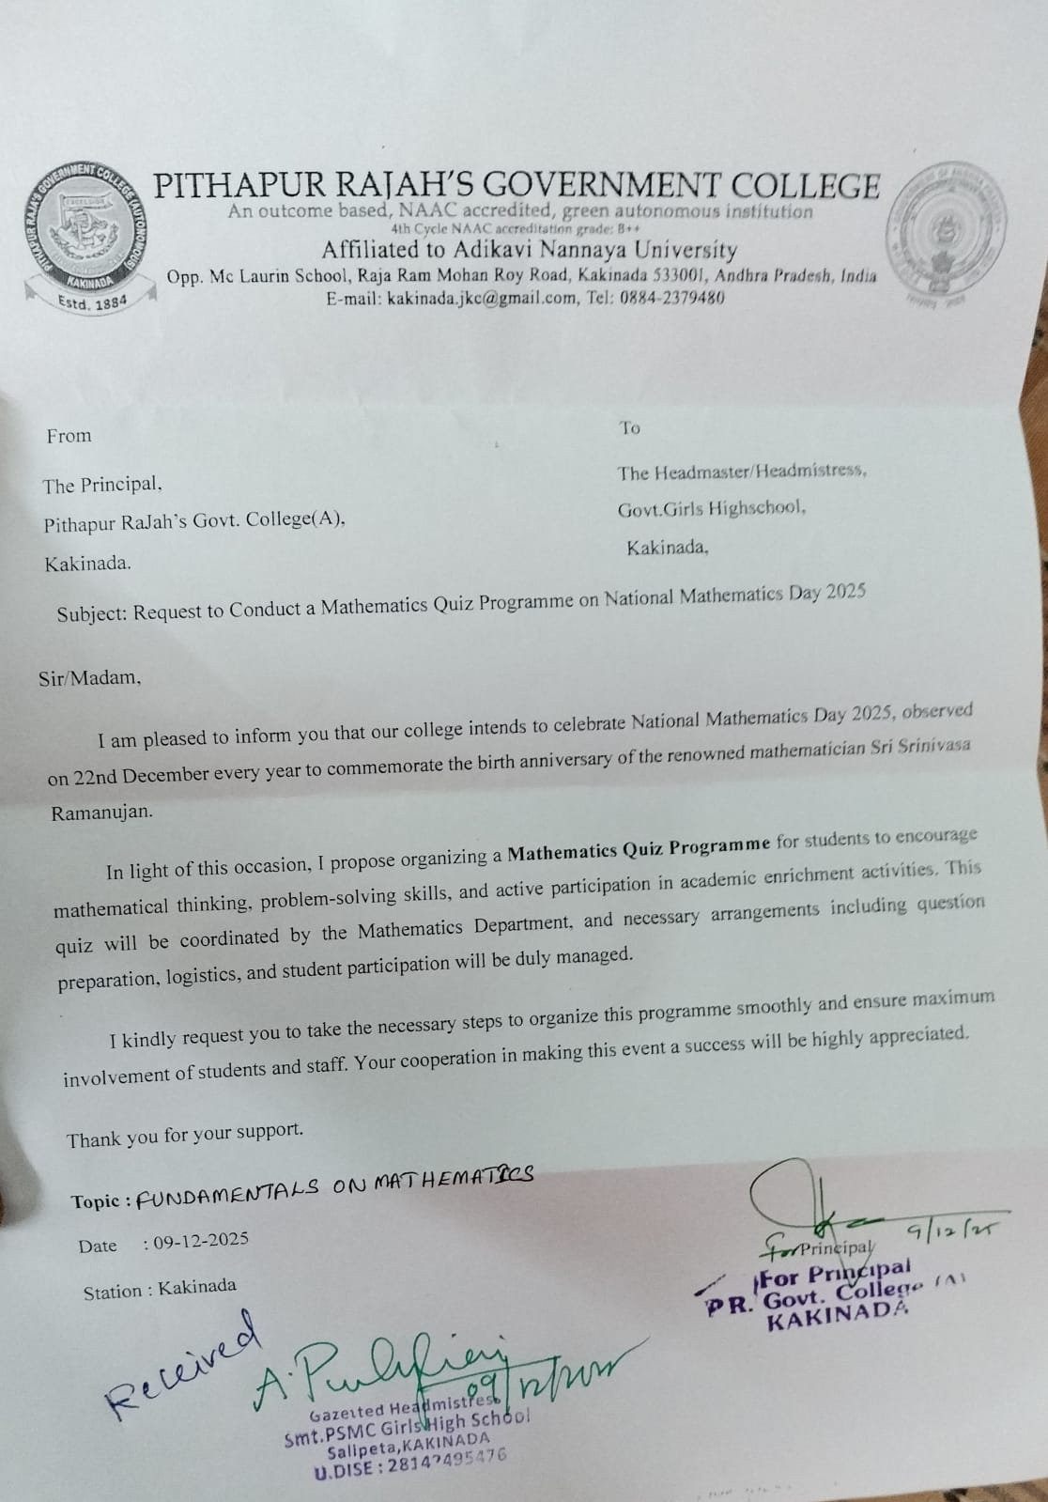
Permission letter for Smt PSMC Girls High School

Permission letter for Mc Laurin High School

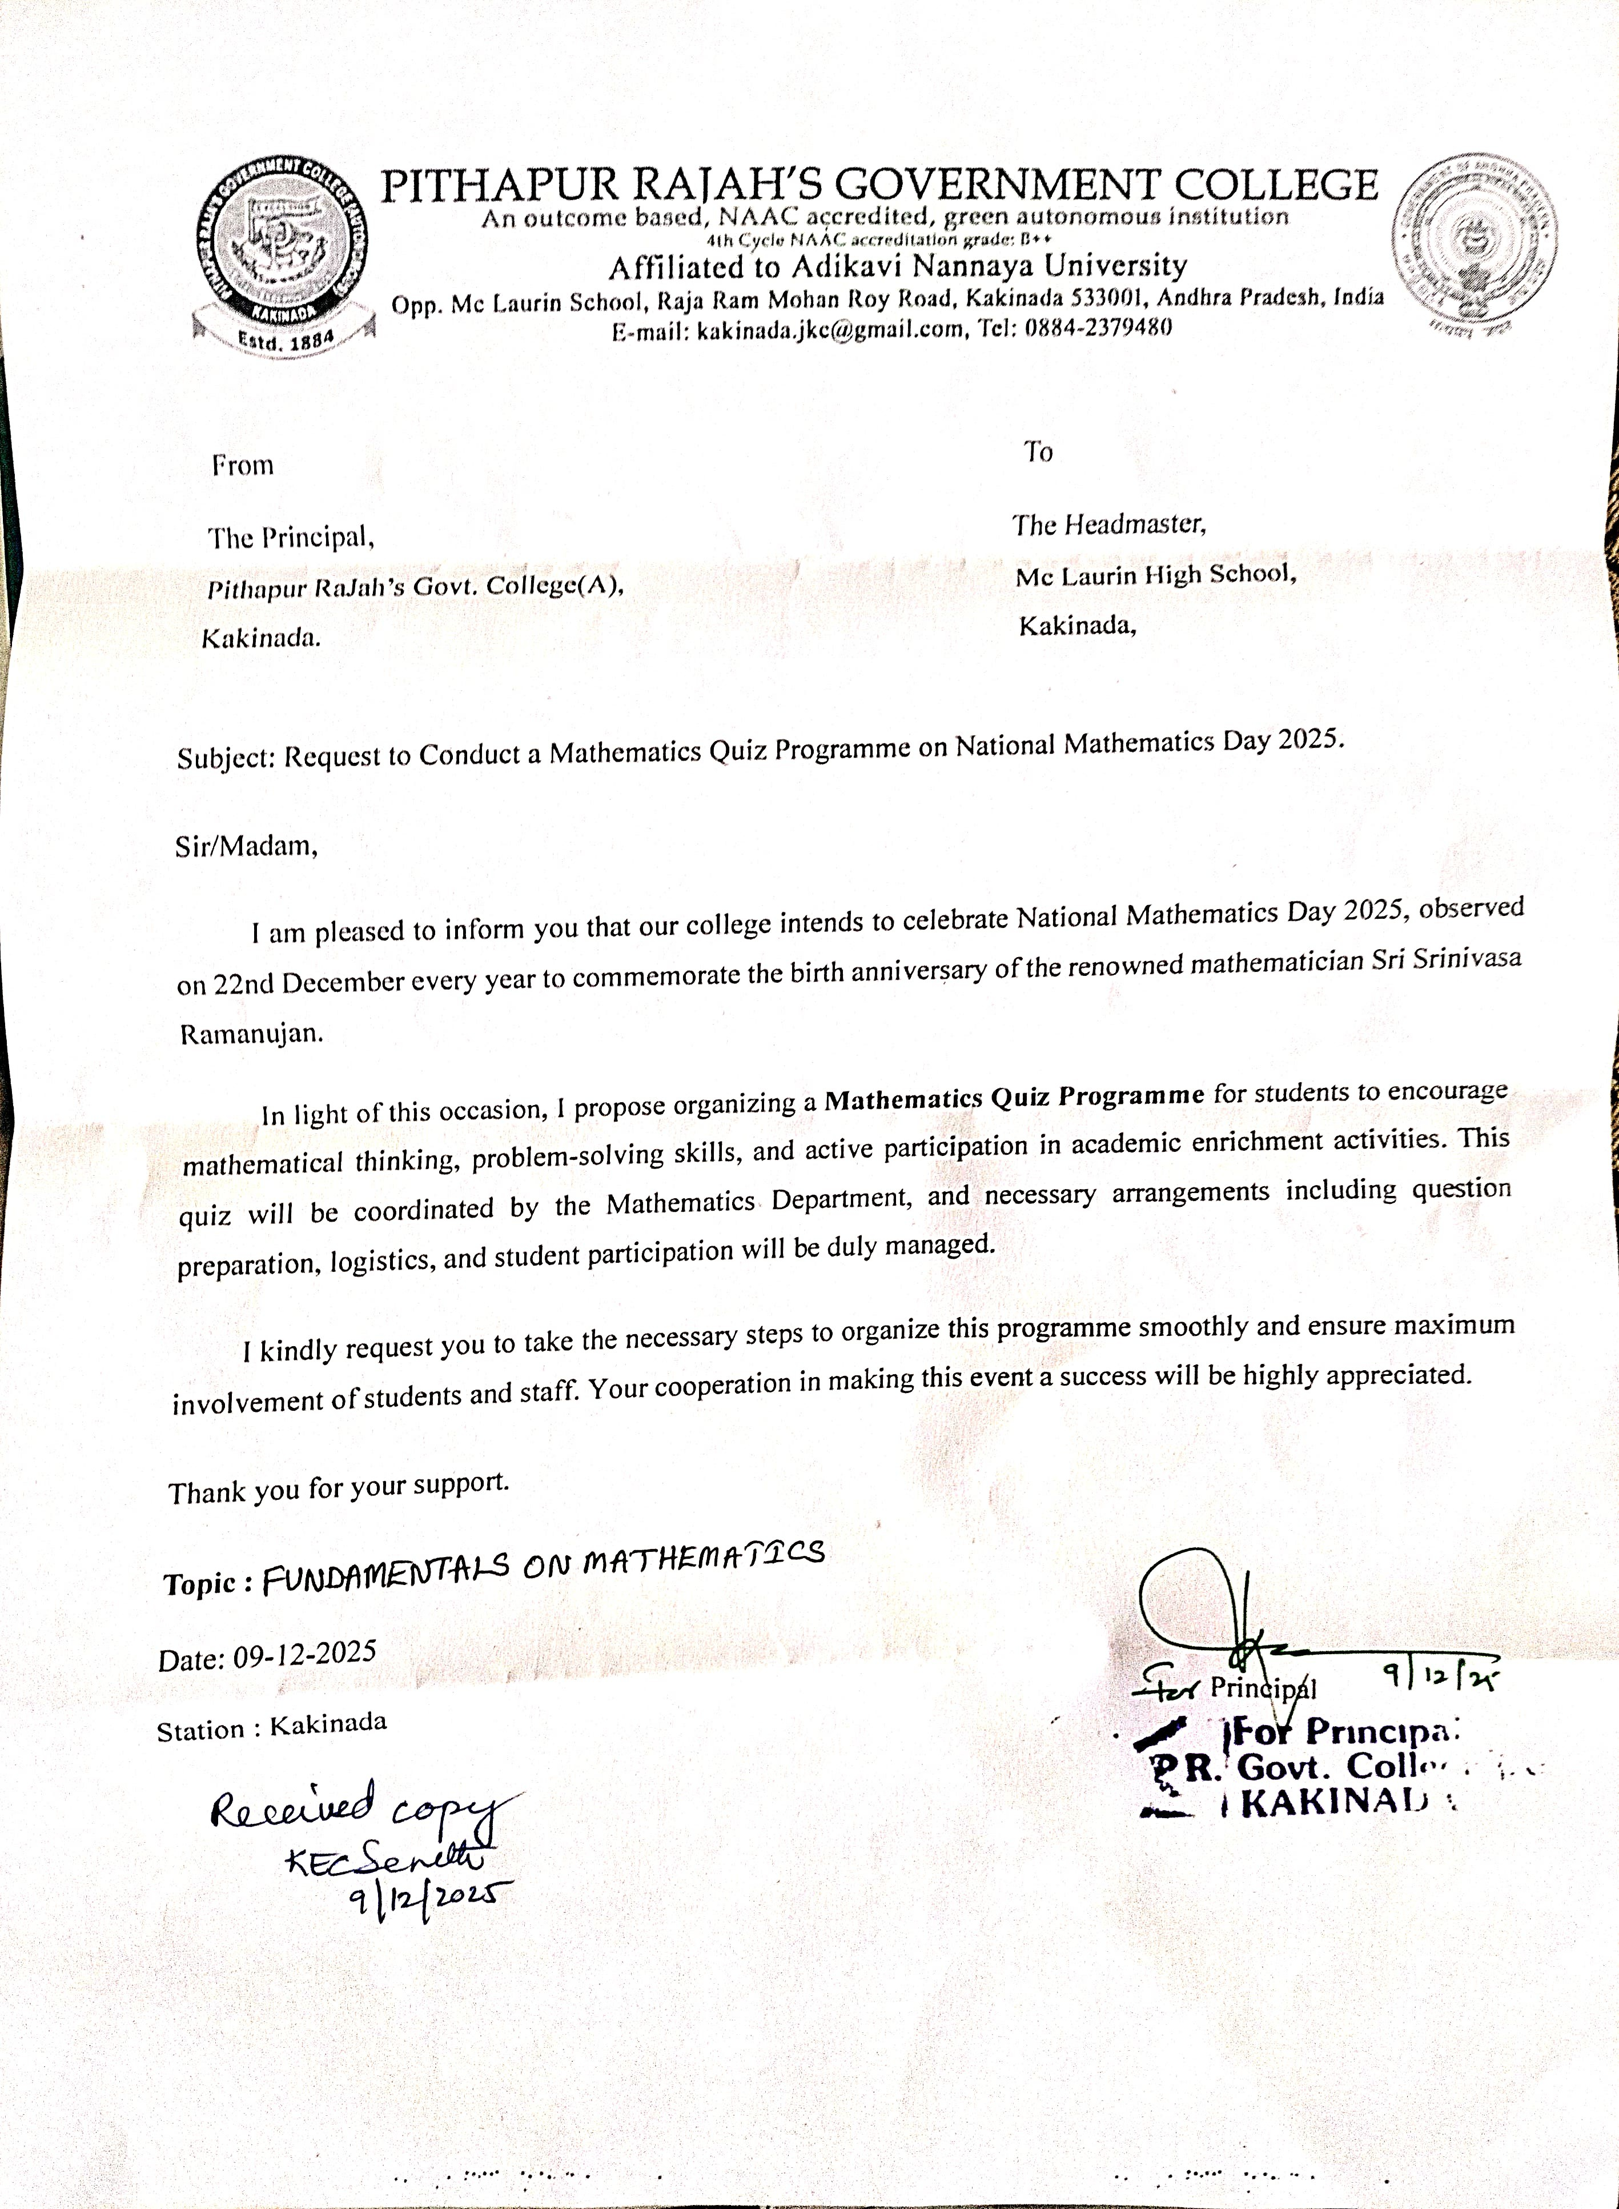

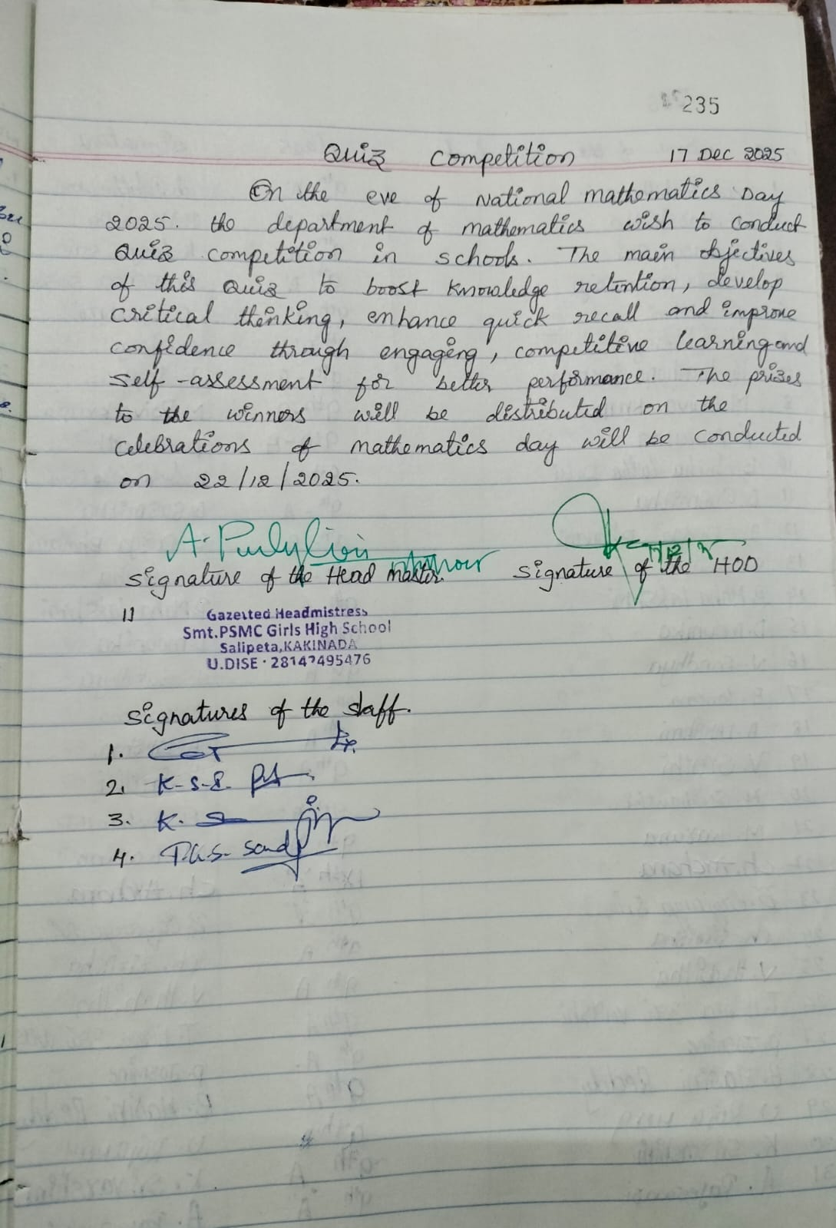
Smt.PSMC Girls High School

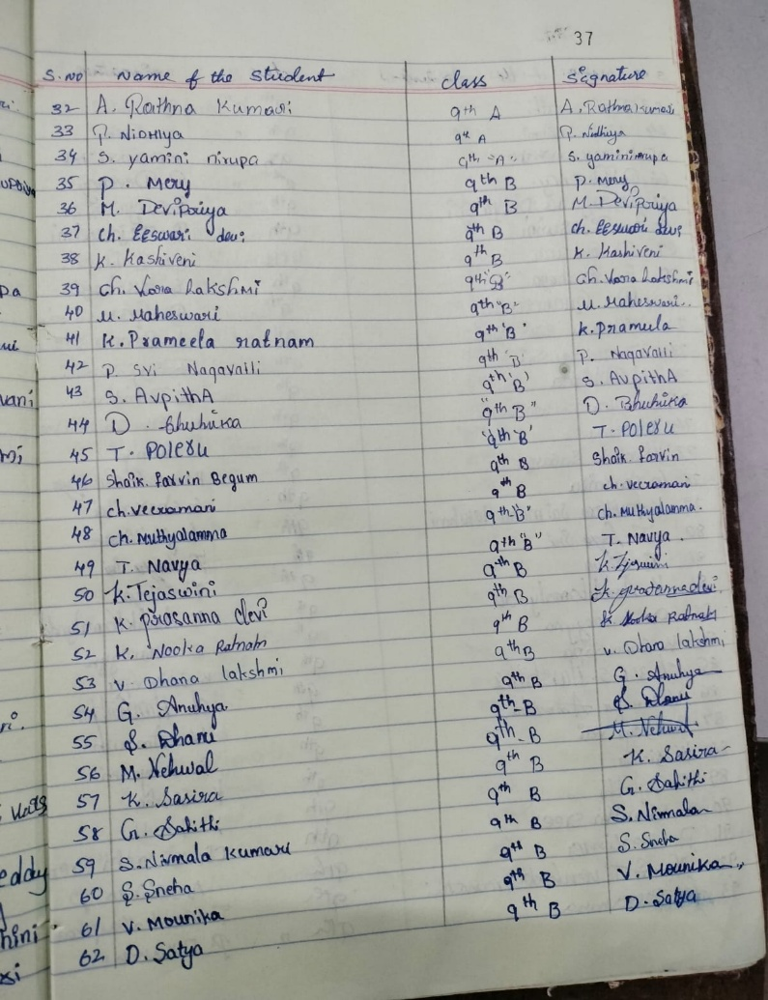
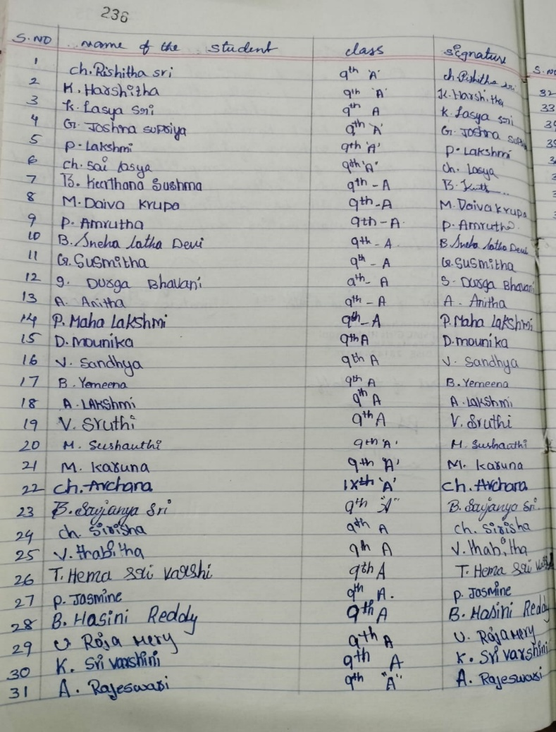

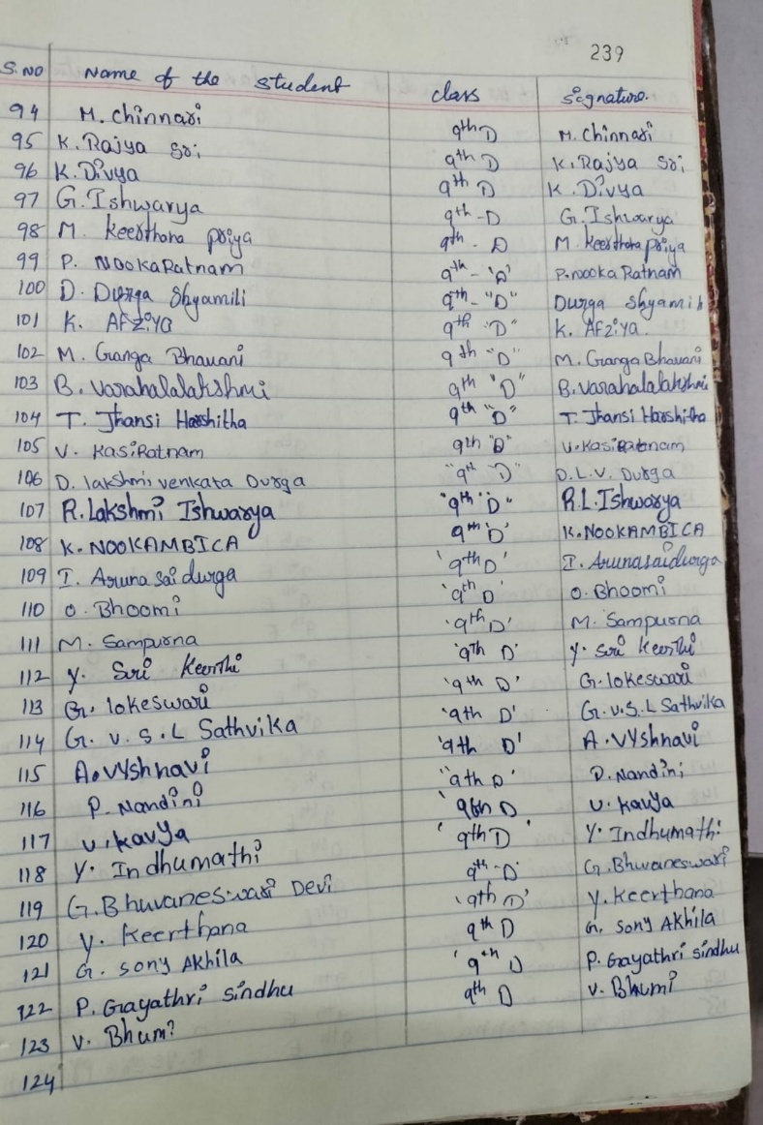
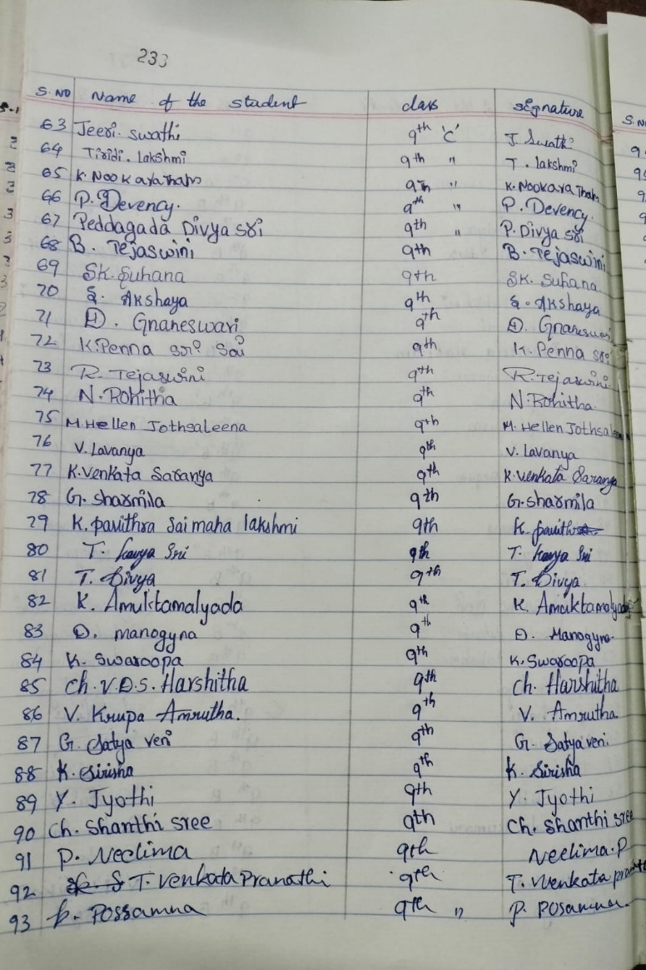
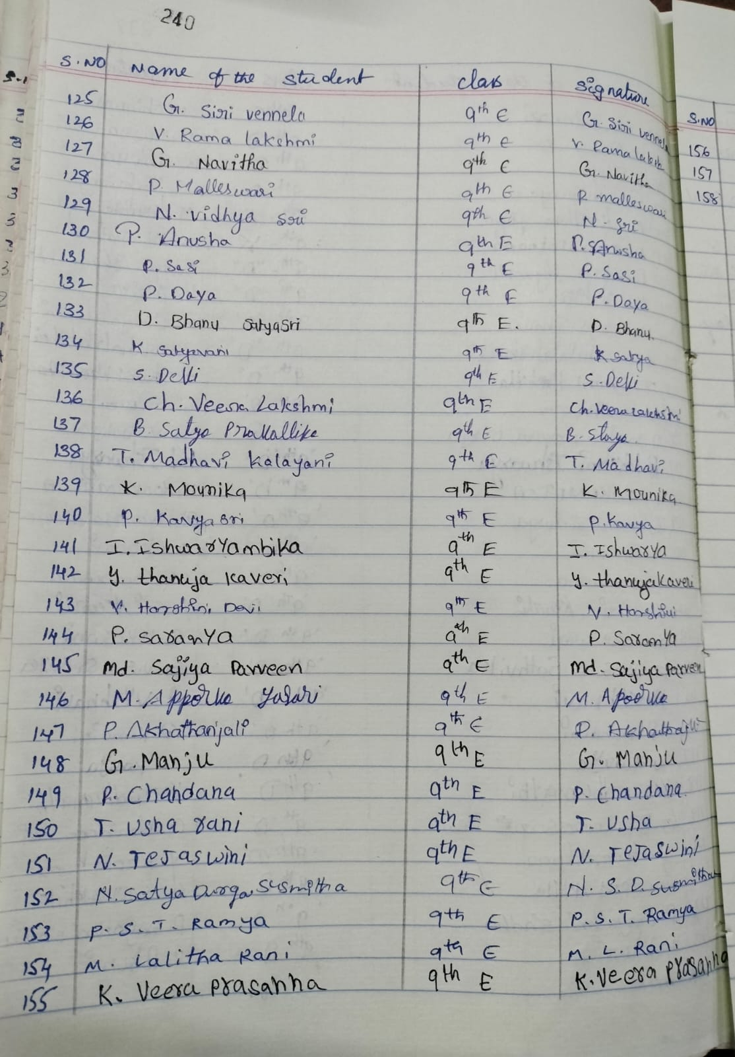

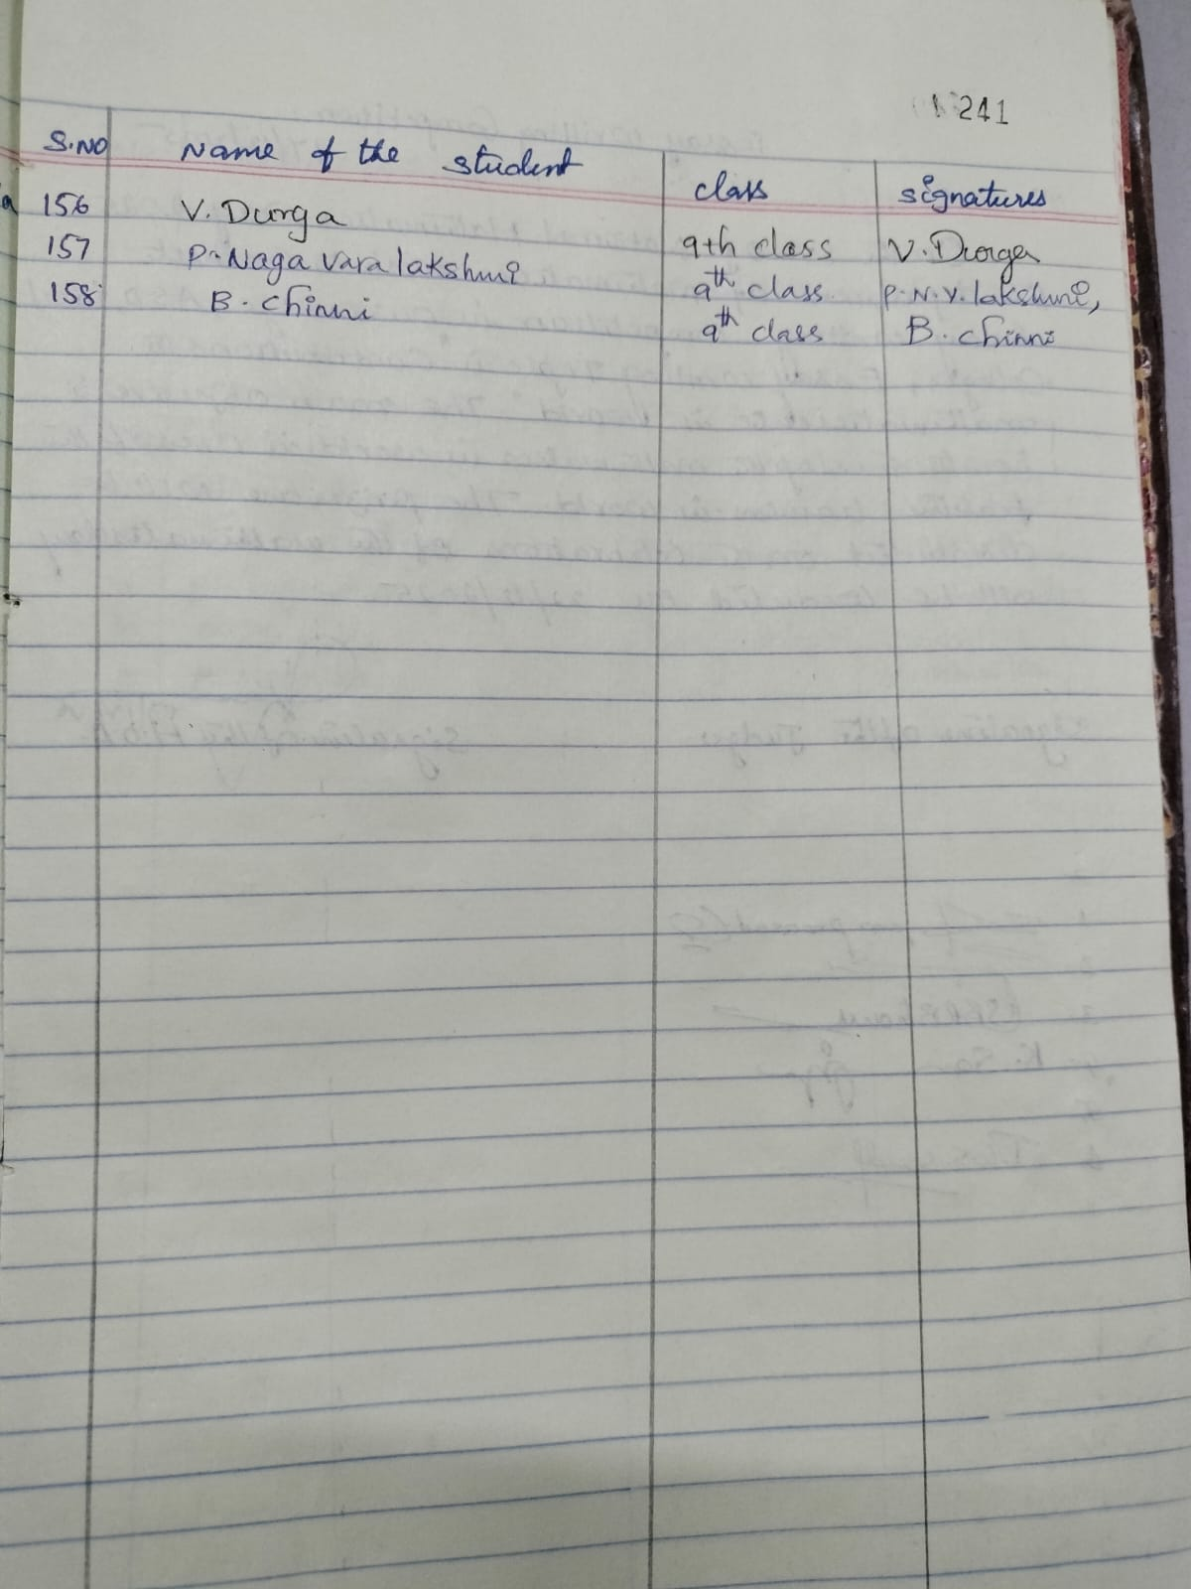

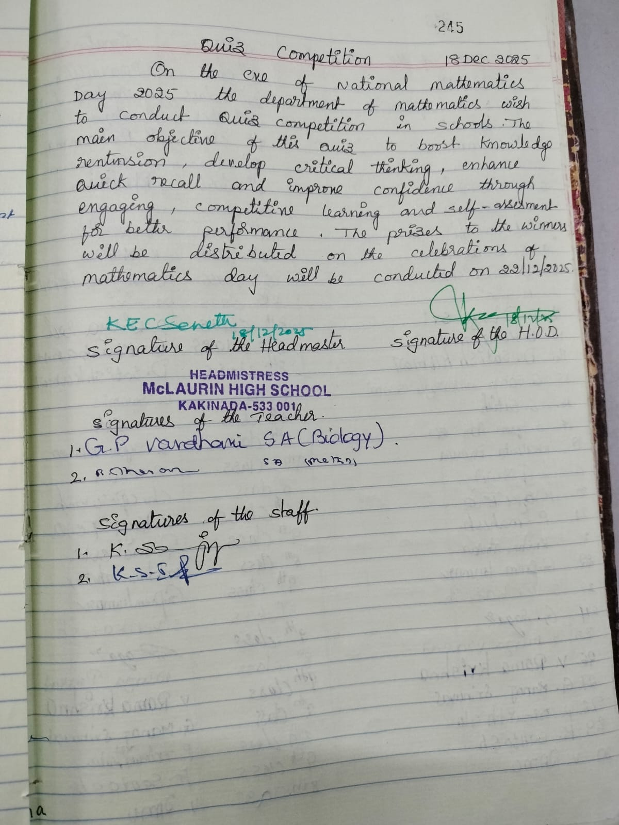
Mc Laurin High School

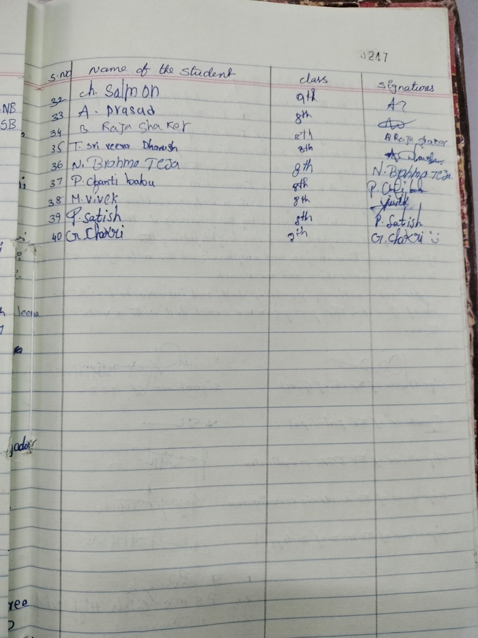
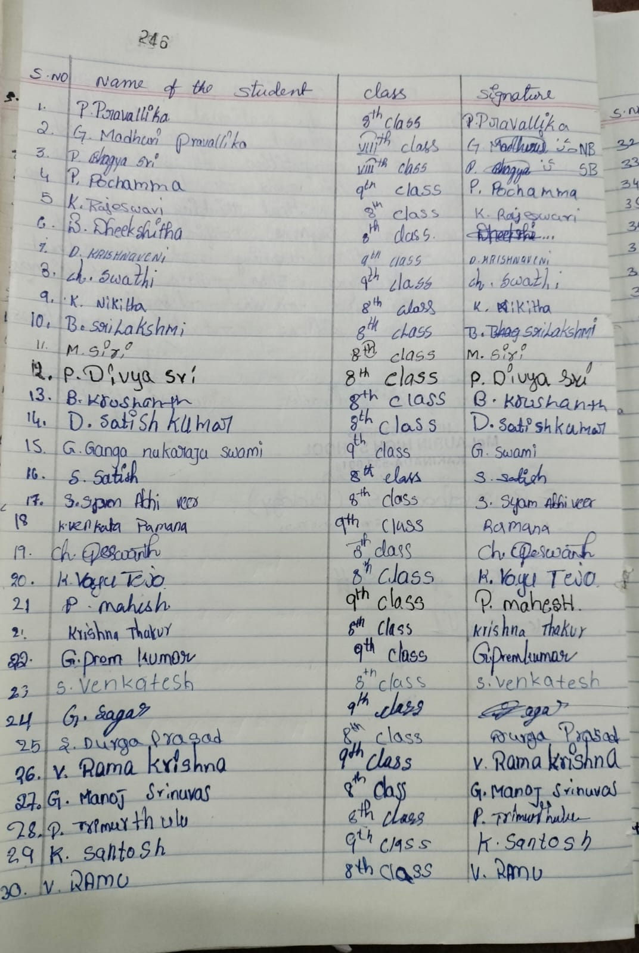

QUIZ PROGRAMME

Topic: General Mathematics

Title of the Activity
“National Mathematics Day – Individual MCQ Quiz on General Mathematics”

Date
17 & 18 December 2025 (Eve of National Mathematics Day)

Organized By
Department of Mathematics

Target Group
Students of Classe IX & X

Mode of Conduct
Offline (Question Paper & OMR Sheet)

Duration
60 Minutes

Objectives of the Activity
- To commemorate the birth anniversary of Srinivasa Ramanujan
- To assess students’ individual understanding of basic mathematical concepts
- To enhance speed, accuracy, and logical reasoning skills
- To motivate students to develop interest in Mathematics
- To promote self-confidence and independent thinking

Description of the Activity
As part of the celebration of National Mathematics Day, an Individual MCQ-Based Mathematics Quiz was organized for school students.
Each participant answered a set of multiple-choice questions covering general mathematics, including arithmetic operations, number systems, geometry, mensuration, algebra, logical reasoning, and real-life applications.
The activity aimed to evaluate individual performance in a stress-free and engaging manner.

Instructions to Participants
- All questions are compulsory
- Each question carries one mark
- Only one option is correct
- Use blue/black pen only
- Calculators and mobile phones are not permitted
- No negative marking

Evaluation & Scoring
- Correct answer: +1 mark
- Wrong / un attempted: 0 mark
- Maximum marks: 25

Declaration of Results
- Answer scripts evaluated by Mathematics teachers
- Results announced on the same day / next day
- Top three scorers awarded prizes

Learning Outcomes
- Improved computational and reasoning skills
- Better conceptual clarity in Mathematics
- Enhanced speed and accuracy
- Increased confidence in independent problem-solving

Follow-Up Activities
- Display of merit list on notice board
- Discussion of solutions in classrooms
- Encouragement of students to participate in future math competitions

Outcome of the Activity
The individual MCQ-based quiz effectively enhanced students’ interest in Mathematics and helped them understand its relevance while commemorating National Mathematics Day in an academic and meaningful manner.

Conclusion
The department of Mathematics has successfully conducted a quiz on Fundamentals on Mathematics at Smt. P.S.M.C Girls High School for 158 students of IX Class students on 17-12-2025.A Quiz on Fundamentals on Mathematics is conducted at Mc. Laurin’s High School for 40 students of VIII &IX Class students on 18-12-2025. Prizes for winners are distributed in the Celebrations of National Mathematics Day-2025.
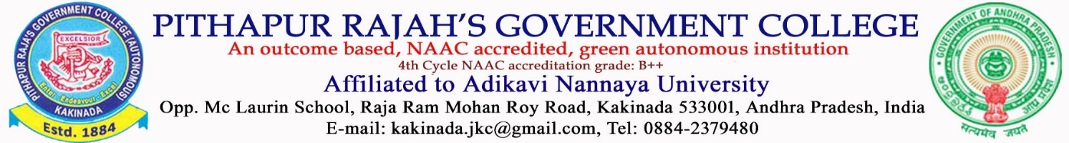
DEPARTMENT OF MATHEMATICS
QUIZ COMPETATION ON THE EVE OF NATIONAL MATHEMATICS DAY – DECEMBER 2025
Name of the Student: Class:
Name of the School: Section:
………………………………………………………………………………………………………………………......
Each question carries ONE mark. Time: 60 Min
SECTION -A
1. Zodiac signs are in all [ ]
A) Ten B) Eleven C) Twelve D) Thirteen
2.H2. How many digits are there in Hindu-Arabic System [ ]
A) 10 B) 20 C) 30 D) 40
3. Who is known as the prince of Indian Mathematics? [ ]
A) Euclid B) Ramanujan C) Pythagoras D) Archimedes
4. Where was Abacus Invented? [ ]
A) China B) Japan C) Germany D) India
5. What is the only number that is spelled in alphabetical order. [ ]
A) Twenty B) Thirty C) Forty D) Fifty
6. Who is the founder of the signs “+ “and “- “in Mathematics [ ]
A) Pythagoras B) John Widman C) Newton D) Euclid
7. If a number is divisible by both 2 and 3, then it is divisible by [ ]
A) 4 B) 5 C) 6 D) 9
8. International Mathematics Day celebrated on [ ]
A)15th Nov B) 22nd Dec C) 15th Oct D) 14th March
9. Who is widely considered to be the Father of Mathematics? [ ]
A) Archimedes B) G.H. Hardy C) Ramanujan D) Gauss
10. What is 7% of 300? [ ]
A) 21 B) 27 C) 18 D) 24
11. Convert 2/5 to a percentage. [ ]
A)10% B)25% C)40% D)45%
12.What is brick called in geometrical terms [ ]
A) Cuboid B) Cube C) Cylinder D) Square
13. How many even prime numbers are there below 20? [ ]
A) 8 B) 9 C) 10 D) 11
14. In which number system there is no symbol for zero? [ ]
A) Hindu Arabic system B) Roman system C) Egyptian system D) Mesopotamia system
15. What is the total number of dots on a dice? [ ]
A) 4 B) 5 C) 6 D) 1
16. What number do you get when you multiply all of the numbers on a telephone number pad? [ ]
A)2 B) 0 C) 6 D) 9
17.If 2024 is divided by 5 then the reminder is? [ ]
A)1 B) 2 C) 3 D) 4
18. Which number does not have a reciprocal [ ]
A)1 B) 2 C) 3 D) 0

19. Who has calculated the circumference of the earth and considered the value of Pi = 22/7? [ ]

A) Archimedes B) John Machin's C) Aryabhata D) None of the above
20. The product of two consecutive natural numbers is always [ ]
A) prime number B) even number C) odd number D) even or odd
21. Who was the author of the book “The man who loved only numbers”? [ ]
A) Paul Erdos B) Paul Hoffman C) Euler D) G.H. Hardy
22.The ratio of girls and boys in a school is 5: 7. If there are 525 girls, how many boys are there? [ ]
A)375 B) 625 C) 735 D) 325
23. ‘a’ raised to the power 0 is equal to [ ]
A)0 B) 1 C) a D) undefine
24. Pythagoras developed a theory about which shapes? [ ]
A) Triangle B) Square C) Rectangular D) Polygon

25.Which among the following is the largest known number in the world? [ ]
A) ∞ B) googol C) googolplex D) gram
FEEDBACK
1. Did you enjoy the quiz? | A) Strongly agree | B) Agree | C) Natural | D) Disagree
2. Has the quiz motivated you? | A) Strongly agree | B) Agree | C) Natural | D) Disagree
3. Did the quiz make you understand and comprehend Mathematics subject better?
A) Strongly agree B) Agree C) Natural D) Disagree
4. You learned something about your personal strengths and weaknesses through the quiz?
A) Strongly agree B) Agree C) Natural D) Disagree
5. In general, are you satisfied with the program?
A) Fully Satisfied B) Satisfied C) Dissatisfied D) Too Dissatisfied

FEEDBACK REPORT
Q.No | Strongly Agree | Agree | Natural | Disagree
Did you enjoy the quiz? | 154 | 36 | 2 | …..
Has the quiz motivated you? | 147 | 24 | 27 | …
Did the quiz make you understand and comprehend  Mathematics subject better? | 175 | 16 | 07 | …
You learned something about  your personal strengths and weaknesses through the quiz? | 168 | 26 | 04 | …
In general, are you satisfied with the program? | 172 | 18 | 08 | …

QUIZ WINNERS
I- Prize: G. ISHWARYA: IX-D SECTION (P. S. M. C. Girls High School)
II– Prize: T. MADHAVI KALYANI: IX -E-SECTION (P. S. M. C. Girls High School)
III– Prize: T. NAVYA IX -B-SECTION (P. S. M. C. Girls High School)
CONSOLATION PRIZE: G. PREM KUMAR: IX CLASS (Mc. Laurin High School)

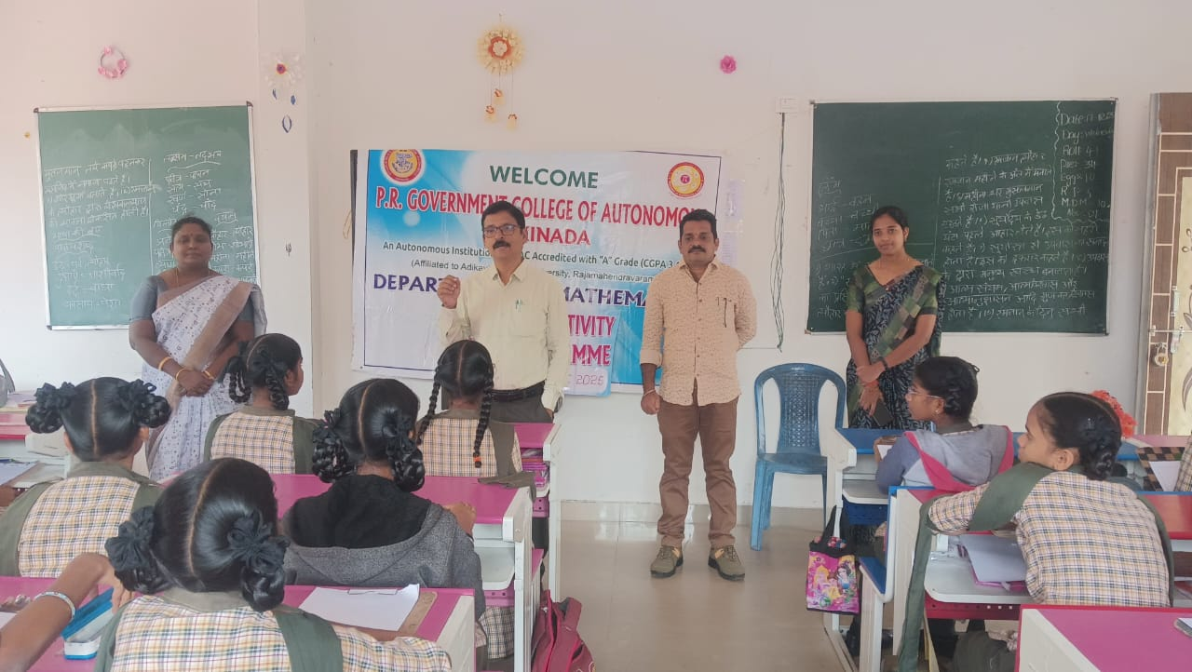
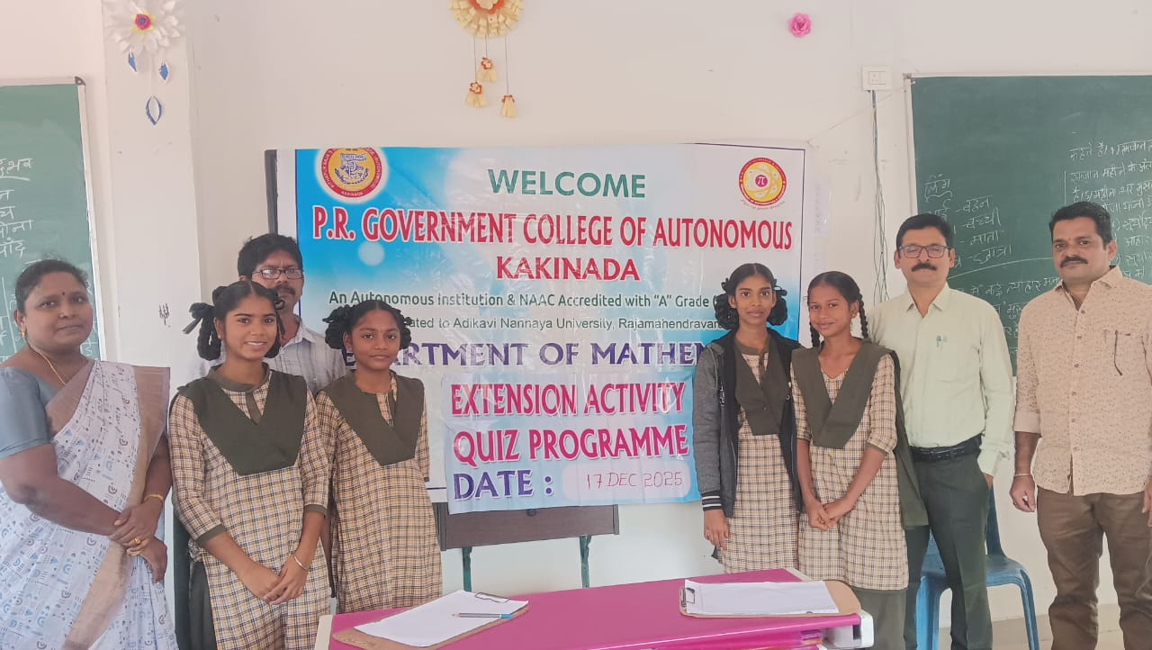
Photo Gallery(Smt.PSMC Girls High School)
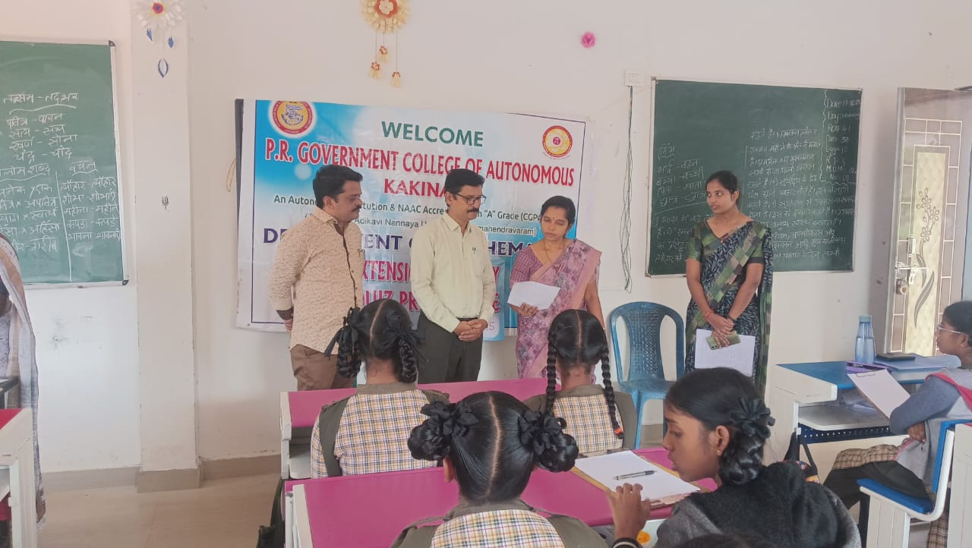
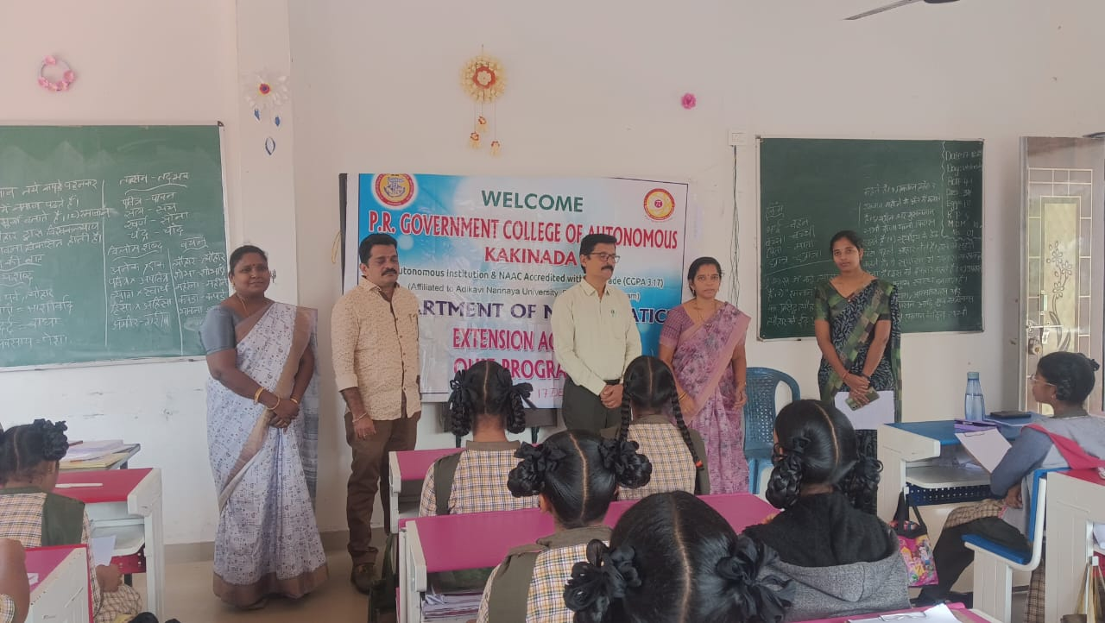

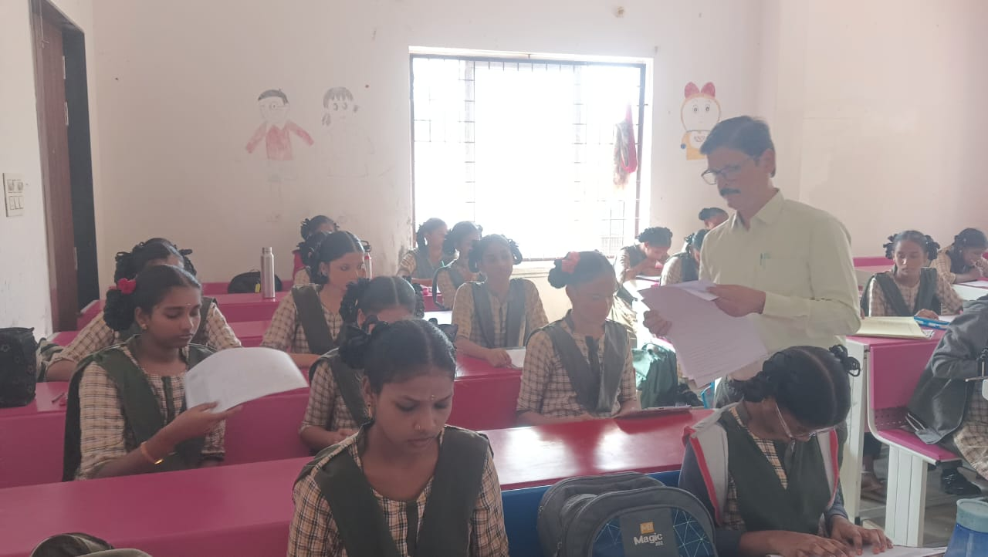
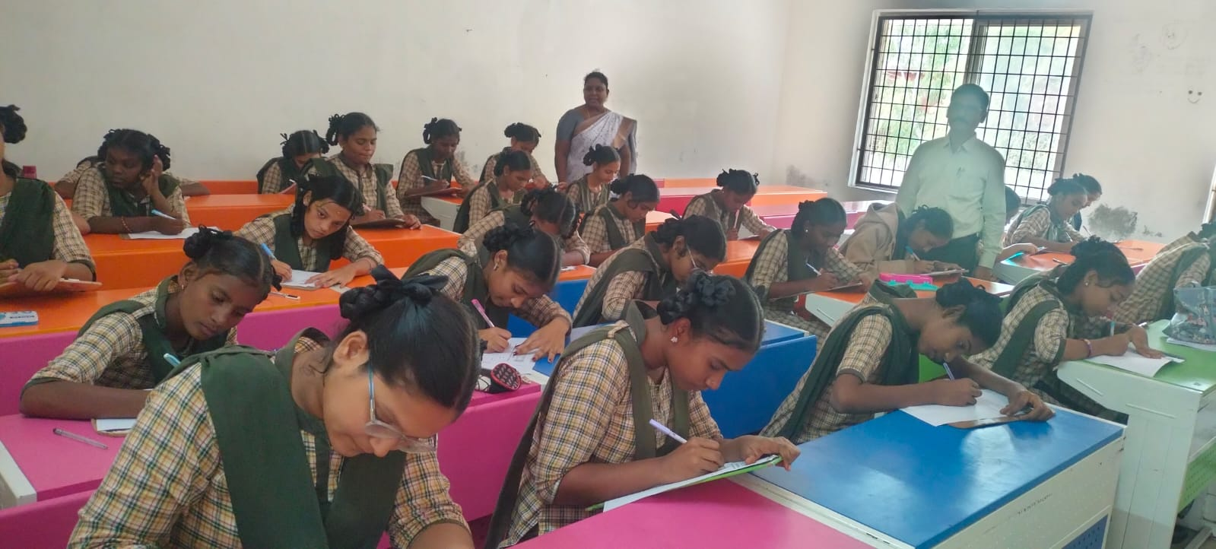
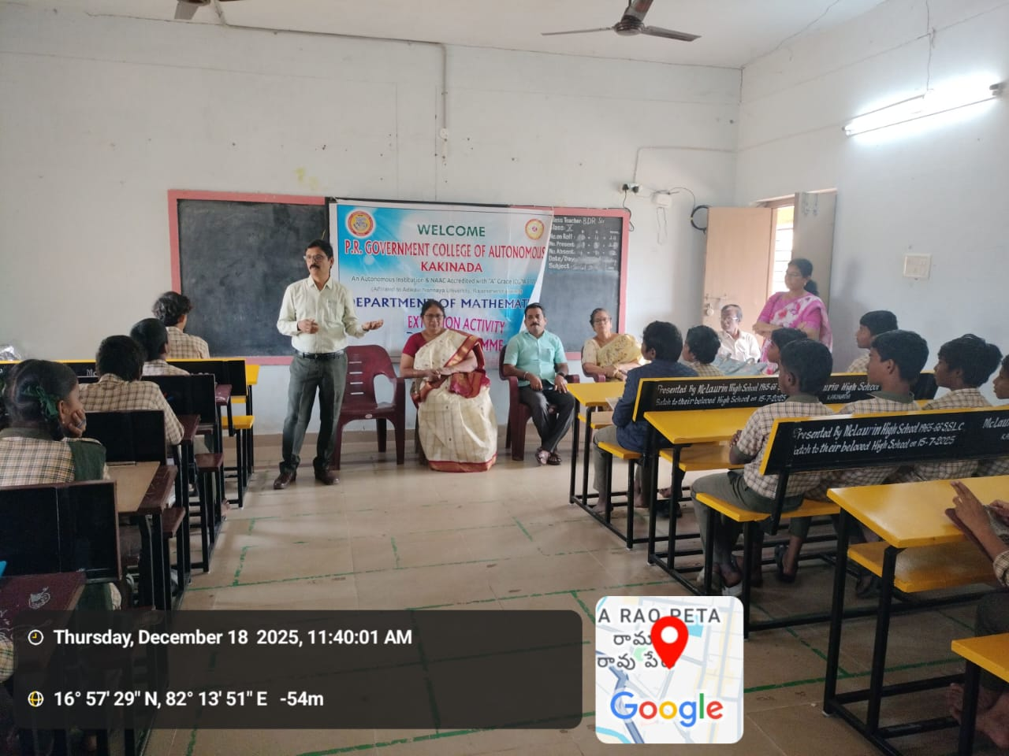
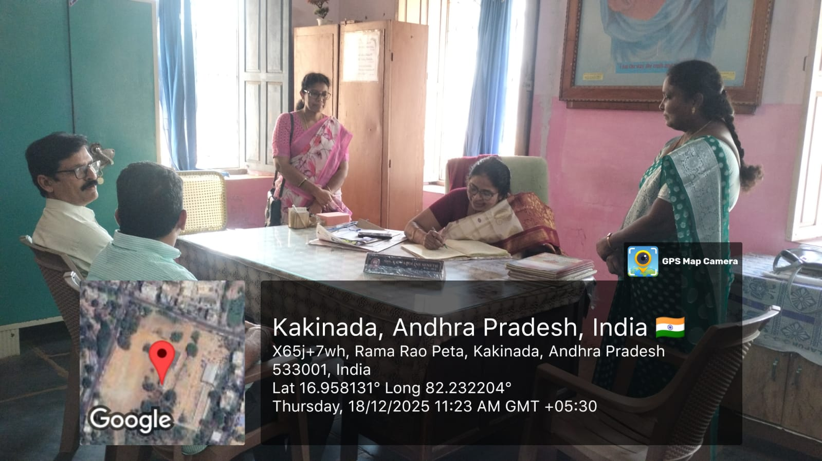
Photo Gallery(Mc Laurin High School)
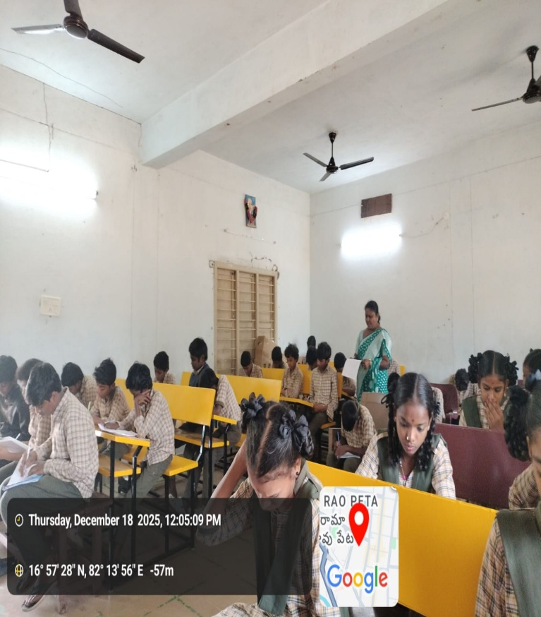
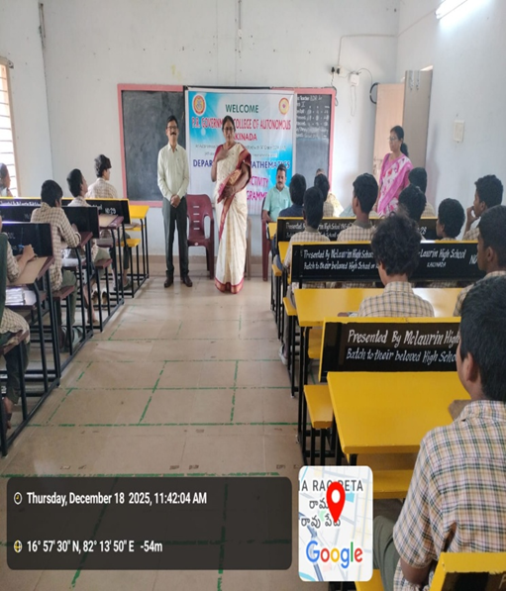

Prize Distribution
